The Land Use Section’s new mission is to advance OAG’s general mission of advocating for the “public interest” in the context of land use and development, including:
Office of the Attorney General (OAG)’s Public Interest Mission
|
  - Proposing text amendments addressing the public interest including affordable housing, racial equity, environmental justice, and procedural equity;
  - Intervening in specific Zoning Commission or Board of Zoning Adjustment cases that raise public interest concerns;
  - Providing resources, training, and support to ANCs, community organizations, and members of the public, to allow them to more effectively participate in the development process.
Who We Are
|

Maximilian Tondro, Section Chief
Maximilian has worked for various D.C. agencies since beginning as a Capital City Fellow in 2012 including the Mayor’s Office of Budget and Finance, the Office of Planning, OAG, DMPED, and DCRA. Maximilian joined the OAG Land Use Section in 2018 and became Chief in 2019. In a prior life, Maximilian served as a Commissioner on the Planning and Zoning Commission of his native Hartford, CT, and was a professor of architectural and urban history.

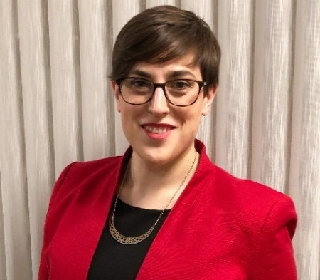
Alexandra Cain, Assistant Attorney General
Alexandra has been with OAG’s Land Use Section since 2019, and before that worked for two years in the D.C. Office of Zoning. Prior to her government service, she worked as a project and construction management consultant for various private clients in DC. Originally from Philadelphia, Alexandra first came to D.C. in 2007 to attend American University for undergrad and later law school.
Current Projects and Goals
|

In 2021, the Land Use Section proposed four text amendments to the Zoning Commission concerning affordable housing and inclusionary zoning:
  - Remove the IZ exemption from Downtown zones;
  - Deepen the affordability of IZ units by lowering the maximum income allowed;
  - Exempt affordable units from parking requirements; and
  - Require enhanced affordable housing benefits for off-site delivery of required IZ units.
In 2022 the Section’s goals include:
  - Advocating for racial equity, affordable housing, environmental justice, displacement, and procedural fairness in zoning and land use development processes;
  - Rolling out a training program for ANCs and community groups; and
  - Working with ANCs, community groups, and residents to identify issues and cases that raise public interest concerns.
How Can the Land Use Section Help You?
|

Case Intervention
The Land Use Section will review issues and cases identified by its attorneys or members of the public to identify public interest issues requiring intervention either through direct intervention in a specific case or advocating for broader policy changes.

Potential Intervention Triggers:
- Displacement of existing residents
- Lack of or insufficient affordable housing
- Environmental Justice
- Procedural equity issues
- Significant neighborhood wide adverse impacts

If you, or your organization, would like to raise a case or issue for intervention, please contact the Land Use Section and provide the following:
- Zoning case number (if applicable)
- Property address
- Details of case/issue of concern
- Concerned or impacted individuals and communities
Training
The Land Use Section will offer trainings to ANCs and community groups tailored to the specific needs and concerns of each group. Some potential topics include:
- Basics of DC Zoning
- ANC “Great Weight”
- Effective participation strategies
- Other policy tools

If you, or your organization is interested in requesting training, please contact the Land Use Section and provide the following:
- Scope of training subject matter
- Intended audience (full ANC, subcommittee, etc.)
- Potential dates and times

Contact Details
|

For more information or questions, please contact us:
Maximilian Tondro Alexandra Cain
Maximilian.Tondro@dc.gov Alexandra.Cain@dc.gov
(202)724-6657 (202) 550-3859

