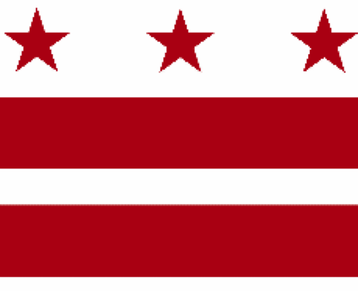

Government of the District of Columbia
ADVISORY NEIGHBORHOOD COMMISSION 3/4G
Chevy Chase, Barnaby Woods, Hawthorne
5601 Connecticut Avenue N.W. P.O. Box 6252 Washington, D.C. 20015
3G@anc.dc.gov | http://www.anc3g.org | YouTube: ANC3G | Office: 202.363.5803

COMMISSIONERS
3/4G-01 - Lisa R. Gore, Vice Chair 3/4G-02 - John Higgins, Treasurer
3/4G-03 - Randy Speck, Chair 3/4G-04 - Michael Zeldin 3/4G-05 - Connie K. N. Chang
3/4G-06 - Peter Gosselin, Secretary 3/4G-07 - Charles Cadwell

____________________________________________________________________________

Agenda
ANC 3/4G Public Meeting
February 14, 2022
Zoom Meeting, 7:00-9:00 pm
Join Video Meeting at https://us02web.zoom.us/j/88617131390
Dial-in number (301) 715-8592
Webinar ID: 886 1713 1390

7:00 Introductions, announcement of meeting procedures (described below), and adoption of agenda

7:05 Commissioner Announcements

7:15 Community Announcements

7:25 Discussion and possible vote on application for a public space permit to extend an existing alley behind 6451 and 6455 Barnaby St NW to allow access to the rear of 6455 Barnaby St NW (TOPS Tracking Number 384882) (Commissioner Gore)

7:50 Discussion and possible vote on Maret’s public space permit application for a curb cut on Nebraska Avenue (Tracking No. 383995) (Commissioners Higgins and Speck)

8:15 DDOT presentation on Oregon Avenue rehabilitation project and its Traffic Safety Investigation Process (Commissioner Gore)

8:40 Report on the Small Area Plan process (Commissioners Chang and Gosselin)

8:55 Report on the Racial and Social Equity Standing Committee (Commissioners Gore and Speck)

9:00 Discussion and possible vote on testimony at the Council’s oversight hearings for the Department of Transportation, Washington Metropolitan Area Transportation Authority, Office of Planning, DC Water, and District of Columbia Public Schools

9:15 Commission Business:

1. Minutes: January 24, 2022
2. Checks:
3. Possible items for February 28, 2022 meeting: report on Small Area Plan process; report on the Racial and Social Equity Standing Committee; presentation by the Ward 4 redistricting task force on ANC and single member district boundaries; discussion and possible vote on development plans for the Lisner-Louise-Dickson-Hurt Home at 5425 Western Avenue, NW (Zoning Case No 21-11); Discussion and possible vote on testimony at the Council’s oversight hearings for the District of Columbia Public Schools

If you are not able to attend the ANC’s public meeting, you may submit your written comments to 3G@anc.dc.gov. Videos of the ANC’s meetings are available on YouTube channel ANC3G.

Virtual Meeting Procedures: The ANC’s meetings are run with a few norms in mind, and we expect everyone to abide by these norms. They promote a civil and respectful discourse.

- Residents are encouraged to send any questions or comments to the Chair at 3G03@anc.dc.gov in advance of the meeting so that they can be addressed during the meeting.
- Except when they are recognized to speak, all attendees to the virtual meeting should mute their devices to avoid disruptions from background noises.
- Meetings will follow the agenda and the times listed there, with any modifications determined by the Chair.
- After a presenter completes his or her statement, Commissioners ask questions, and then residents have an opportunity to ask their questions or make comments.
- During meetings, residents should use the chat function to ask questions or to request to make a comment; they will then be recognized by the Chair.
- Speakers must limit any statements or questions to the time allotted. The Commission also accepts emailed and written comments or questions.
- Every resident will have an opportunity to be heard once on an issue before any resident is heard twice.
- We understand that sometimes issues may provoke strong emotions and that these expectations may be forgotten. Part of the Chair’s job is to remind you of these norms during the meeting.

