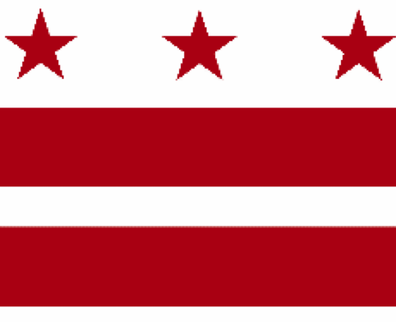

Government of the District of Columbia
ADVISORY NEIGHBORHOOD COMMISSION 3/4G
Chevy Chase, Barnaby Woods, Hawthorne
5601 Connecticut Avenue N.W. P.O. Box 6252 Washington, D.C. 20015
3G@anc.dc.gov http://www.anc3g.org YouTube: ANC3G Office: 202.363.5803

COMMISSIONERS
3/4G-01 - Lisa R. Gore, Vice Chair 3/4G-02 - John Higgins, Treasurer
3/4G-03 - Randy Speck, Chair 3/4G-04 - Michael Zeldin 3/4G-05 - Connie K. N. Chang
3/4G-06 - Peter Gosselin, Secretary 3/4G-07 - Charles Cadwell

____________________________________________________________________________

February 14, 2022
Washington, DC

Ernest Chrappah
Director
DC Department of Consumer and Regulatory Affairs
1100 Fourth Street SW
Washington, DC 20024

Dear Director Chrappah;
I am writing on behalf of ANC 3/4G, which authorized this letter at its February 14, 2022 meeting by a vote of XX to XX, to ask your department to take two steps in connection with the American City Diner property at 5532 Connecticut Avenue NW.

To recap, the diner closed in July 2018, a year after the death of its owner Jeffrey Gildenhorn. Initially, prospects for the site seemed bright after restaurateur
Steve Salis leased the facility and proposed first a brassiere and later a bakery at the location. DCRA analyzed and was prepared to approve initial proposals. But as COVID bore down on the city and the world, Salis shelved his plans. The property has been up for lease for the past 18 months.

The Commission is sympathetic to the challenges the pandemic is creating for small businesses, especially food establishments. But the diner has been allowed to deteriorate to the point that neighbors now express concerns about rat infestations and potential health issues. Adjacent businesses seem likely to be suffering as a result of the eyesore the property presents. In addition, it appears that the leasing agent, KLNB, may be taking improper liberties in marketing the property.

As a result, we ask, first, that your department inspect the property to determine whether it is blighted under DC Code § 42–3131.05. If you determine it is, we believe you will find that it is no longer exempt from penalties under DC tax law. We ask that you recommend it be taxed as a Class 4 blighted property.

[[Insert mention of ANC’s longstanding concern about vacant and blighted?]]

Secondly, we ask that your department review whether KLNB is violating DC billboard regulations that are part of the DC Building Code in using the space above the diner, which previously had carried public art, to advertise the fact the property is up for lease. While there may be an exemption from the regulations for advertising lease or sale of a property, it seems unlikely this does not solve the problem for KLNB because the specific message it is displaying is that the space is available to be leased for a commercial message, a use that we question whether the regulations permit. We are appending an analysis by attorney Larry Hargrove that was recently posted on a local social media site, the Chevy Chase listserv.

I would be happy to speak with you about this issue at your earliest convenience. I am reachable essentially 24/7 via email or at 202-251-3945. I will contact DCRA’s liaison to our ANC to make sure that person is aware of our letter and concerns.

Sincerely,

Peter Gosselin

Commissioner 3/4G-06

Larry Hargrove review of the American City Dinner billboard issue

as posted on the Chevy Chase listserv, Friday, February 11, 2022

"The billboard near the intersection of Connecticut and Morrison is in violation of District Regulations found in Appendix N of the Building Code.
"By way of background, in 1931 the District, faced with a proliferation of unsightly billboards, enacted regulations that contained a list of then-existing billboards and allowed those billboards to remain in place; they could be maintained if they obtained a permit that required them to meet a detailed set of conditions as to size, location, lighting, etc. Any billboards not on the list had to be taken down unless they could similarly qualify for and obtain such a permit.
"These provisions, including the list of “authorized billboards”, were updated in 1972, and remain in the DC code of regulations today as part of the Building Code. They included provisions designed to protect neighborhoods and neighborhood-serving commercial strips from large-scale outdoor advertising. These included prohibiting billboards in or within 200 feet of a residential zone, and prohibiting their erection on lots that have less than fifty feet of street frontage. Additionally, billboards were required to be set back from the lot line by at least one foot.

"Whether or not the billboard at Connecticut and Morrison was on the “authorized” list compiled in 1931 – which seems unlikely, -- it is required to meet these conditions, which it does not do. Specifically, it is located less than 200 feet from a residential zone (R-2), from which it is separated only by an alley and a few additional feet; is not set back from the lot line, and is erected on a lot that apparently has less than fifty feet of street frontage."

