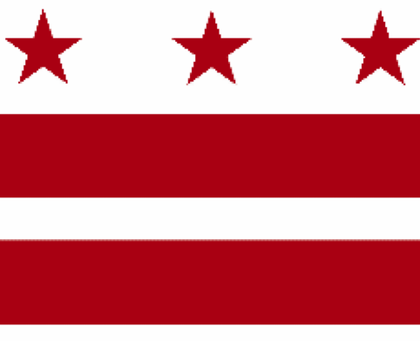

Government of the District of Columbia
ADVISORY NEIGHBORHOOD COMMISSION 3/4G
Chevy Chase, Barnaby Woods, Hawthorne
5601 Connecticut Avenue N.W. P.O. Box 6252 Washington, D.C. 20015
3G@anc.dc.gov | http://www.anc3g.org | YouTube: ANC3G | Office: 202.363.5803

COMMISSIONERS
3/4G-01 - Lisa R. Gore, Vice-Chair 3/4G-02 - John Higgins, Treasurer
3/4G-03 - Randy Speck, Chair 3/4G-04 - Michael Zeldin 3/4G-05 - Connie K. N. Chang
3/4G-06 - Peter Gosselin, Secretary 3/4G-07 - Charles Cadwell

____________________________________________________________________________

ANC 3/4G Testimony Before the
Committee on Housing and Executive Administration
FY 2023 Budget Hearing on the
Office of the City Administrator (Office of Racial Equity)
April 7, 2022

Chairperson Bonds and members of the Committee on Housing and Executive Administration, I am Randy Speck, Chair of ANC 3/4G (Chevy Chase), and I am testifying on behalf of our Commission, which authorized this testimony at its March 28, 2022 meeting by a vote of _ to _ (a quorum being 4).
In June 2020, ANC 3/4G adopted a Statement on Racism and created a Task Force on Racism to identify equity and justice issues within our community and to propose concrete solutions. The Task Force through its work groups worked over the summer and fall of 2020 to develop a number of recommendations. One recommendation by the Community Work Group was “development of a Racial Response Network that would provide a means for quick, confidential, and safe reporting of racially motivated incidents that occur in the community. In response to an incident, the Network would help victims decide what course of action to pursue, ranging from confidential discussion to police reporting.” Those who seek to report or discuss racial incidents and issues frequently encounter difficulties, and the Network would provide a confidential, safe way to report and resolve those concerns. The goal is to ensure that people of all races and backgrounds feel supported and welcome in the community.
The Commission adopted this recommendation at its January 25, 2021 public meeting. The Commission also created a standing committee on Racial and Social Equity (RASE) and among its charges was developing this Network.
On March 11, 2022, representatives of the RASE Committee met with Dr. Amber Hewitt, Director of the Office of Racial Equity (ORE), and her staff to discuss creation of a Racial Response Network that would serve more than just ANC 3/4G.
Key to support for those who experience a racially motivated incident is a quick, meaningful, and prioritized response. This includes having an individual phone call between the victim and a response team member who could listen and provide support. Because of the presumed personal nature of the incident, possible responses may include an in-person visit from the response team, connecting the victim with neighbors, or referral to applicable resources to receive support. The support action may also include constituting a small group that could take quick action to remedy or repair any physical damage to property (e.g., remove graffiti) or to assist the victim in notifying/connecting with social services, the police or other agencies.
Many details for the Network will need to be developed by and with the assistance of the ORE. It may be appropriate to begin the Network as a pilot program in a few ANCs — including ANC 3/4G — that can be expanded to other Commissions across the District. It will also be necessary to coordinate with other District agencies — e.g., the Metropolitan Police Department, the Office of the Attorney General, the Office of Unified Communications, and the Office of the Chief Technology Officer. To be effective, there will also need to be significant community outreach so that those who may be affected by racial incidents will know where they can go to get assistance.
If this Network is to become a reality, it must be funded. Our Commission urges the Council to direct ORE to be responsible for creating this Network and to include funding for one FTE at ORE in the FY 2023 budget to initiate this effort. The ORE should report to the Council on its progress in developing the Network, its outreach efforts, the numbers of incidents, and the results achieved.
Based on our experience, we believe that this Network is needed in our community and across the District. The ORE should take the lead in creating the Network and working with ANCs to ensure its success. We would appreciate the Council’s support for this important initiative.
Thank you.

Chevy Chase ANC Task Force On Racism – Community Work Group, November 12, 2020, page 4.
ANC 3/4G Meeting Minutes, January 25, 2021.
Questions of legal liability also will need to be addressed.

