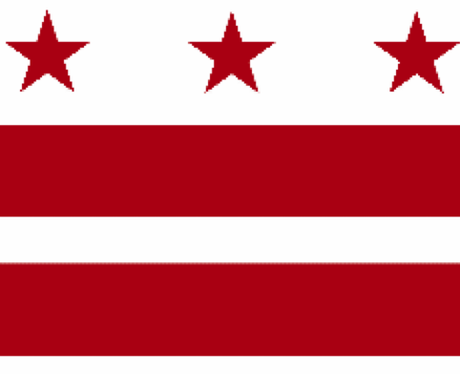

Government of the District of Columbia
ADVISORY NEIGHBORHOOD COMMISSION 3/4G
Chevy Chase, Barnaby Woods, Hawthorne
5601 Connecticut Avenue N.W. P.O. Box 6252 Washington, D.C. 20015
3G@anc.dc.gov | http://www.anc3g.org | YouTube: ANC3G | Office: 202.363.5803

COMMISSIONERS
3/4G-01 - Lisa R. Gore, Vice-Chair 3/4G-02 - John Higgins, Treasurer
3/4G-03 - Randy Speck, Chair 3/4G-04 - Michael Zeldin 3/4G-05 - Connie K. N. Chang
3/4G-06 - Peter Gosselin, Secretary 3/4G-07 - Charles Cadwell

____________________________________________________________________________

ANC 3/4G Testimony Before the
Committee on Transportation and the Environment
FY 2023 Budget Hearing
Department of Energy and Environment
March 29, 2022

Chairperson Cheh and members of the Committee on Transportation and the Environment, I am Randy Speck, Chair of ANC 3/4G. Thank you for the opportunity to testify about the Department of Energy and Environment’s (DOEE’s) budget for FY 2023. I am testifying on behalf of our Commission, which authorized this testimony at its properly noticed March 28, 2022 public meeting by a vote of _ to _ (a quorum being 4). In addition, I am one of two public representatives appointed by the Council to the Lead Service Line Replacement Task Force (LSL Task Force) created as part of the Fiscal Year 2022 Budget Support Act of 2021. My testimony focuses on DOEE’s proposed budget as it relates to lead service line (LSL) replacement.
Lead free water should be a fundamental right of all District residents and it should be provided to DC Water customers without cost. DOEE plays a crucial role in protecting District residents’ health because it dispenses and oversees federal funding to DC Water to replace LSLs. DC Water has committed to remove all of those LSLs by 2030. Last year, we urged the Council to allocate the $350 million that DC Water and DOEE’s Director had requested to remove all LSLs. At that time, DC Water estimated that this project would cost about $1 billion, even though the costs incurred in other cities suggest that the District should require no more than about $228 million.
Congress has earmarked money for LSL replacement in the American Recovery Plan Act (ARPA) and the Infrastructure Investment and Jobs Act. DOEE’s proposed budget includes $10 million from ARPA that it will provide to DC Water in FY 2023 for LSL replacement. Additional federal funds should be made available and should not be diverted to any other purpose. In addition, DC Water recently committed to supplement federal appropriations and to fully fund LSL replacement through its capital improvement plan. Under this plan, however, DC Water expects that customers will pay for this commitment through expected rate increases.
The LSL Task Force is addressing funding sources for LSL replacement, and both the Task Force and the Council’s independent contractor are examining the reasonable costs for replacing all of the District’s LSLs by 2030. These analyses and recommendations may not be available before the Council must approve the FY 2023 budget. Nevertheless, we urge the Council to include provisions in the Budget Support Act that will require DOEE to ensure that all federal and local funds for LSL replacement are used solely for that purpose and not for DC Water’s other capital improvements, e.g., water main replacement that is not required for LSL replacement. DOEE should require that DC Water itemize and transparently report how it uses federal and local funds.
The LSL Task Force is also examining ways to make the block-by-block LSL replacement more efficient and thereby reduce costs. This block-by-block approach should be more cost-effective than past piecemeal programs, which should be phased out to the greatest extent possible. In beginning to implement block-by-block replacements, however, DC Water has experienced a high rate of customer rejections — even when customers bear none of the costs. DC Water may be able to reduce the number of those rejections through better communications with customers, but the rate of customer rejection may still be too high to permit an efficient block-by-block program. Thus, the LSL Task Force will likely recommend that the Council enact a mandate that will require customers to allow DC Water to replace LSLs on their property and will provide customers with filters and other measures to protect themselves before and after replacement. Other jurisdictions have adopted such mandates as the best way to address these concerns.
District residents have lived with the acknowledged health hazard posed by LSL for decades. DOEE, other District agencies, DC Water, and the Council must now use all available resources and tactics to fully rid the District of this unacceptable threat.
Thank you.

See “FY 2023 Proposed Budget and Financial Plan,” March 16, 2022, Volume 4, Agency Budget Chapters — Part III, (Proposed Budget) pages F-15 through F-25.
D.C. Code § 34–2162.
ANC 3/4G Testimony Before the Committee on Transportation and the Environment FY 2022 Budget Hearing Department of Energy and Environment, June 14, 2021.
DC Water, Lead Service Line Replacement Plan, June 2021, page 10.
Finishing the Job of Getting Safe Water to the Tap: How Much Does it Cost to Replace Lead Service Lines?, Elin Warn Betanzo, Safe Water Engineering, LLC, October 2021, page 16.
Proposed Budget, page F-25. This proposed federal allocation for FY 2023 is less than the $15 million that the Mayor proposed in DOEE’s FY 2022 budget. The approved budget reallocated these funds for other purposes. “FY 2022 Approved Budget and Financial Plan,” September 17, 2021, Volume 4, Agency Budget Chapters — Part III, page F-31.
See DC Water Board of Directors Meeting, March 3, 2022. page 25.
See City of Newark Code Title XVI, ch. 16:23, Mandatory Replacement of Lead Service Lines.

