Government of the District of Columbia

ADVISORY NEIGHBORHOOD COMMISSION 3/4G
Chevy Chase, Barnaby Woods, Hawthorne
5601 Connecticut Avenue N.W. P.O. Box 6252 Washington, D.C. 20015
3G@anc.dc.gov | http://www.anc3g.org | YouTube: ANC3G | Office: 202.363.5803
COMMISSIONERS
3/4G-01 - Lisa R. Gore, Vice Chair 3/4G-02 - John Higgins, Treasurer
3/4G-03 - Randy Speck, Chair 3/4G-04 - Michael Zeldin 3/4G-05 - Connie K. N. Chang
3/4G-06 - Peter Gosselin, Secretary 3/4G-07 - Charles Cadwell
Resolution Regarding Proposed
Single Member District Boundaries
For the Ward 4 Portion of ANC 3/4G
March 10, 2022
Ward 4 Redistricting Task Force:
Advisory Neighborhood Commission 3/4G (Chevy Chase, Barnaby Woods, and Hawthorne), based on discussion at a special public meeting held on March 10, 2022, offers the following resolution regarding redistricting of the Ward 4 portion of ANC 3/4G.
- As our Commission Chair testified at the Ward 4 Redistricting Task Force’s February 6, 2022 meeting — with the unanimous support from all ANC 3/4G commissioners — we urge the Task Force to preserve ANC 3/4G to include all of the Chevy Chase, Barnaby Woods, and Hawthorne neighborhoods. This cross-Ward commission keeps these communities with common interests together and has worked well for 20 years. It should be preserved, as recognized in all of the Task Force’s discussion maps.
- The Commission, having reviewed the four discussion maps proposed by the committee, supports maps 1 or 2 for the following reasons:
  - Moving the small section of 3/4G03 into Ward 3 makes sense. The Commission understands and supports the desire to confine single member districts to one ward, however, we can’t say that a split SMD disserves constituents. The split SMD that is in our ANC has been well served by their commissioner for over a decade.
  - Moving the area between McKinley Street and Morrison Street from 3/4G04 into 3/4G03 makes sense to ensure greater parity among the districts that constitute our ANC.
  - Maps 1 and 2 continue to allow the current commissioners to represent their existing districts. We understand that the redistricting process should not be designed to preserve the district of any particular commissioner. We support this principle. It is the view of our Commission, however, that it is important that constituents have continuity of representation when possible. The Commission sees no reason for a significant, disruptive change in the existing boundaries.
  - Maps 1 and 2 preserve the structure of our Commission which allows the workload of the Commissioners to be equally divided. For example, SMD
3/4G01 has the northern part of Oregon Avenue, Chestnut Street, Western
Avenue, and Pinehurst Circle and tributary. SMD 3/4G02 has part of
Oregon Avenue, St. John’s College High School, Knollwood, and the
Episcopal Center for Children. SMD 3/4G04 has Lafayette Elementary School and the Lafayette-Pointer Recreation Center and Park. SMD 3/4G03 has Ingleside, the Carnegie Institute, and Military Road.
  - Maps 1 and 2 preserve the Hawthorne area in one district. This area is best served by one commissioner. To the extent that issues that principally touch on Hawthorne such as the reduction of bus service, one commissioner best serves this constituency.
- The Commission does not support Map 4. The boundaries within it make little sense in terms of commissioner workload, continuity of representation (Map 4 would gerrymander two of our seven commissioners out of their districts), representation of geographic areas that should not be subdivided, and the overall best interests of our community.
- For the reasons outlined above, the Commission recommends that the Ward 4 Redistricting Task Force adopts either maps one or two as it relates to ANC 3/4G and that it supports continuation of a combined ANC 3/4G that includes SMDs from both Ward 3 and Ward 4.
ADOPTED at ANC 3/4G’s properly noticed special public meeting on March 10, 2022, by a vote of 7 yes, 0 no, 0 abstentions (a quorum being 4).
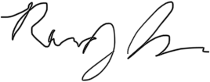
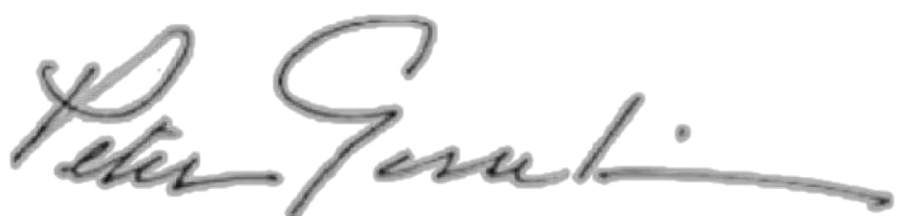
___________________________ __________________________
Randy Speck, Chair Peter Gosselin, Secretary

The Commission offers no opinion on the redistricting of any other single member districts in Ward 4, and it may separately offer its views to the Ward 3 Redistricting Task Force on single member district boundaries for the Ward 3 portion of ANC 3/4G.
We have been advised that map 3 is incorrectly drawn as it relates to 3/4G. We withhold comment on it until a corrected map is furnished to our Commission.

