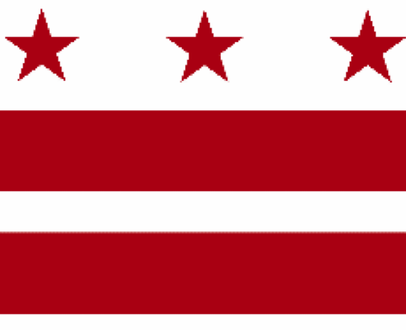

Government of the District of Columbia
ADVISORY NEIGHBORHOOD COMMISSION 3/4G
Chevy Chase, Barnaby Woods, Hawthorne
5601 Connecticut Avenue N.W. P.O. Box 6252 Washington, D.C. 20015
3G@anc.dc.gov | http://www.anc3g.org | YouTube: ANC3G | Office: 202.363.5803

COMMISSIONERS
3/4G-01 - Lisa R. Gore, Vice Chair 3/4G-02 - John Higgins, Treasurer
3/4G-03 - Randy Speck, Chair 3/4G-04 - Michael Zeldin 3/4G-05 - Connie K. N. Chang
3/4G-06 - Peter Gosselin, Secretary 3/4G-07 - Charles Cadwell

____________________________________________________________________________

Agenda
ANC 3/4G Public Meeting
March 28, 2022
Zoom Meeting, 7:00-9:00 pm
Join Video Meeting at https://us02web.zoom.us/j/83091560736
Dial-in number (301) 715-8592
Webinar ID: 830 9156 0736

7:00 Introductions, announcement of meeting procedures (described below), and adoption of agenda

7:05 Commissioner Announcements

7:15 Community Announcements

7:30 Discussion and possible vote on public space permit application by Blue 44 to install awing for its sidewalk cafe (Tracking No. 391206) (Commissioner Chang)

7:40 Presentation by and discussion with the Office of Campaign Finance on the agency’s Traditional and Public Financing Fair Elections Programs (Commissioner Speck)

8:00 Discussion with DCPS Chancellor Ferebee on the DCPS Budget for FY 2023 (Commissioner Zeldin)

8:30 Report on the Small Area Plan process (Commissioners Chang and Gosselin)

8:45 Report on the Racial and Social Equity Standing Committee (Commissioners Gore and Speck)

8:50 Discussion and possible vote on testimony at Council’s FY 2023 budget hearings for the Department of Energy and Environment, Deputy Mayor for Planning and Economic Development, Department of Parks and Recreation, Department of Transportation, DC Public Library, Office of the City Administrator (Office of Racial Equity) (Commissioners Chang, Gore, Speck)

9:00 Commission Business:

1. Minutes: February 24, 2022, February 28, 2022, March 10, 2022, March 14, 2022
2. Checks:
3. Possible items for April 11, 2022 meeting: discussion with DDOT regarding its Traffic Safety Investigation process; discussion of the draft Chevy Chase Small Area Plan;

If you are not able to attend the ANC’s public meeting, you may submit your written comments to 3G@anc.dc.gov. Videos of the ANC’s meetings are available on YouTube channel ANC3G.

Virtual Meeting Procedures: The ANC’s meetings are run with a few norms in mind, and we expect everyone to abide by these norms. They promote a civil and respectful discourse.

- Residents are encouraged to send any questions or comments to the Chair at 3G03@anc.dc.gov in advance of the meeting so that they can be addressed during the meeting.
- Except when they are recognized to speak, all attendees to the virtual meeting should mute their devices to avoid disruptions from background noises.
- Meetings will follow the agenda and the times listed there, with any modifications determined by the Chair.
- After a presenter completes his or her statement, Commissioners ask questions, and then residents have an opportunity to ask their questions or make comments.
- During meetings, residents should use the chat function to ask questions or to request to make a comment; they will then be recognized by the Chair.
- Speakers must limit any statements or questions to the time allotted. The Commission also accepts emailed and written comments or questions.
- Every resident will have an opportunity to be heard once on an issue before any resident is heard twice.
- We understand that sometimes issues may provoke strong emotions and that these expectations may be forgotten. Part of the Chair’s job is to remind you of these norms during the meeting.

