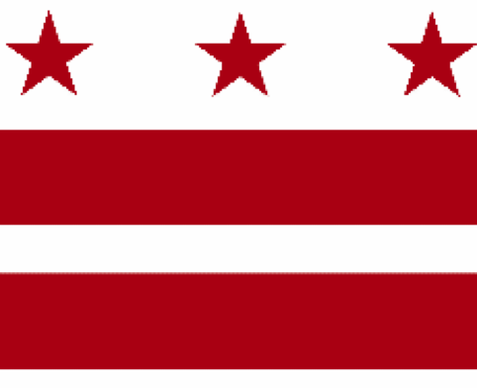

Government of the District of Columbia
ADVISORY NEIGHBORHOOD COMMISSION 3/4G
Chevy Chase, Barnaby Woods, Hawthorne
5601 Connecticut Avenue N.W. P.O. Box 6252 Washington, D.C. 20015
3G@anc.dc.gov http://www.anc3g.org YouTube: ANC3G Office: 202.363.5803

COMMISSIONERS
3/4G-01 - Lisa R. Gore, Vice-Chair 3/4G-02 - John Higgins, Treasurer
3/4G-03 - Randy Speck, Chair 3/4G-04 - Michael Zeldin 3/4G-05 - Connie K. N. Chang
3/4G-06 - Peter Gosselin, Secretary 3/4G-07 - Charles Cadwell

____________________________________________________________________________

ANC 3/4G Testimony Before the
Committee on Housing and Neighborhood Revitalization
Budget Hearing on the
Department of Aging and Community Living
March 23, 2022

Chairperson Bonds and members of the Committee on Housing and Neighborhood Revitalization, I am Randy Speck, Chair of ANC 3/4G (Chevy Chase), and I am testifying on behalf of our Commission, which authorized this testimony at its March 14, 2022 meeting by a vote of _ to _ (a quorum being 4).
ANC 3/4G has long advocated for a brick-and-mortar senior wellness center in Ward 3. The Commission’s June 27, 2016 resolution called on the Mayor, the DC Office on Aging, the Department of Parks and Recreation, and the Councilmembers representing Wards 3 and 4 “to establish a fully-funded senior wellness center for Wards 3 and 4 West of Rock Creek Park by 2017.” Regrettably, our seniors continue to be underserved without a physical senior wellness center that is reasonably accessible to them.
The District Department of Aging and Community Living (DACL) operates six physical senior wellness centers located in Wards 1, 4, 5, 6, 7, and 8. DACL also supports a “virtual” senior wellness center — AroundTownDC — for Wards 2 and 3. AroundTownDC provides a valuable service by sponsoring activities and connecting seniors to these and other available activities, and the Commission has supported its efforts in February 2020 testimony before the Council. It does not, however, address seniors’ critical need for a physical place to gather and to receive wellness services.
Census data shows that Ward 3 has a higher concentration of seniors than the rest of the District — about 17% of the Ward 3 residents are age 65 and older compared with about 13% District-wide. Social isolation is a problem for older adults that affects both their physical and mental health and is linked to more rapid cognitive decline. More than 58% of DC’s older adults live alone, running a greater risk of social isolation. Senior wellness centers are a significant element in the District’s strategy for addressing this social isolation among older adults. The permanent staff at a wellness center can also observe changes in seniors’ health and economic challenges and can provide proactive support that is not available on a virtual platform.
The District’s Comprehensive Plan Policy Map designates significant portions of Ward 3 along the Connecticut Avenue and Wisconsin Avenue corridors as Future Planning Analysis Areas, and the Office of Planning is currently engaged in detailed planning processes for those corridors in Chevy Chase, Friendship Heights, Tenleytown, Cleveland Park, and Woodley Park. The Lisner-Louise-Dickson-Hurt Home is also planning an expansion that may include community space. These initiatives can and should include planning for a senior wellness center.
Based on the persistent, acute need for a physical wellness center to serve seniors west of Rock Creek Park, we urge the Council to include at least $100,000 in the FY 2023 budget to conduct an options and visioning study to examine how to build on the achievements of AroundTownDC, incorporate the strengths of wellness centers in other wards and communities, assess seniors’ transportation needs, and identify potential sites for and the feasibility of a brick-and-mortar senior wellness center located in Ward 3. This study should be coordinated with the Office of Planning’s ongoing planning initiatives in Ward 3.
Thank you.

This testimony reiterates the Commission’s January 24, 2022 resolution.
“A Portrait of D.C.’s Older Adults,” DC Policy Center, June 22, 2018.
Rock Creek West Roadmap, District Office of Planning, December 16, 2021, page 16.

