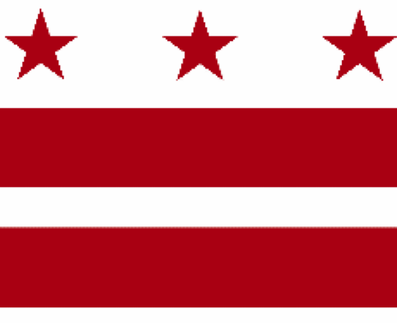

Government of the District of Columbia
ADVISORY NEIGHBORHOOD COMMISSION 3/4G
Chevy Chase, Barnaby Woods, Hawthorne
5601 Connecticut Avenue N.W. P.O. Box 6252 Washington, D.C. 20015
3G@anc.dc.gov | http://www.anc3g.org | YouTube: ANC3G | Office: 202.363.5803

COMMISSIONERS
3/4G-01 - Lisa R. Gore, Vice Chair 3/4G-02 - John Higgins, Treasurer
3/4G-03 - Randy Speck, Chair 3/4G-04 - Michael Zeldin 3/4G-05 - Connie K. N. Chang
3/4G-06 - Peter Gosselin, Secretary 3/4G-07 - Charles Cadwell

____________________________________________________________________________

Agenda
ANC 3/4G Public Meeting
May 23, 2022
Zoom Meeting, 7:00-9:00 pm
Register for Video Meeting here

7:00 Introductions, announcement of meeting procedures (described below), and adoption of agenda

7:05 Commissioner Announcements

7:15 Community Announcements

7:20 Discussion and possible vote on liquor license renewals for Blue 44 (License Number: ABRA-085977), the Parthenon Restaurant and Chevy Chase Lounge (License Number: ABRA-013995), Little Beast (License Number: ABRA-109091), and Bread and Chocolate (ABRA-007792) (Commissioners Chang and Gosselin)

7:35 Presentation by and discussion with Isaac Boateng, Account Manager, Office of the Director, Department of Consumer and Regulatory Affairs (Commissioner Chang)

7:50 Discussion with Lafayette Elementary Local School Advisory Team (LSAT) (Commissioner Zeldin)

8:15 Discussion with DDOT regarding its Traffic Safety Investigation process (Commissioner Zeldin)

8:35 Presentations on and discussions of the “District of Columbia Tip Credit Elimination Act of 2021” (Initiative 82) (Commissioner Speck)

8:55 Presentation by Brianne Dornbush on Chevy Chase Main Street and grant opportunities (Commissioner Speck)

9:10 Commission Business:

1. Minutes: April 11, 2022, April 25, 2022, May 9, 2022
2. Checks:
3. Possible items for June 13, 2022 meeting: discussion and possible vote on resolution to support the “Enhancing Reproductive Health Protections Amendment Act of 2022” (BA24-0726) before the District Council and the “Women’s Protection Act of 2021” (HR 3755) before the U.S. Congress

If you are not able to attend the ANC’s public meeting, you may submit your written comments to 3G@anc.dc.gov. Videos of the ANC’s meetings are available on YouTube channel ANC3G.

Virtual Meeting Procedures: The ANC’s meetings are run with a few norms in mind, and we expect everyone to abide by these norms. They promote a civil and respectful discourse.

- Residents are encouraged to send any questions or comments to the Chair at 3G03@anc.dc.gov in advance of the meeting so that they can be addressed during the meeting.
- Except when they are recognized to speak, all attendees to the virtual meeting should mute their devices to avoid disruptions from background noises.
- Meetings will follow the agenda and the times listed there, with any modifications determined by the Chair.
- After a presenter completes his or her statement, Commissioners ask questions, and then residents have an opportunity to ask their questions or make comments.
- During meetings, residents should use the chat function to ask questions or to request to make a comment; they will then be recognized by the Chair.
- Speakers must limit any statements or questions to the time allotted. The Commission also accepts emailed and written comments or questions.
- Every resident will have an opportunity to be heard once on an issue before any resident is heard twice.
- We understand that sometimes issues may provoke strong emotions and that these expectations may be forgotten. Part of the Chair’s job is to remind you of these norms during the meeting.

