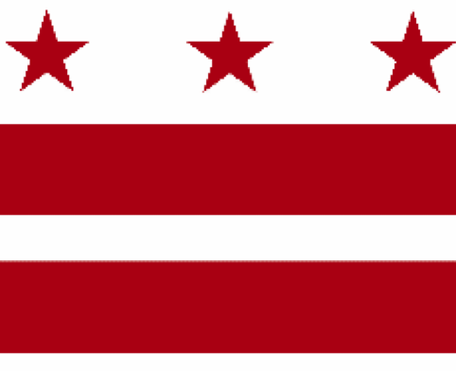

Government of the District of Columbia
ADVISORY NEIGHBORHOOD COMMISSION 3/4G
Chevy Chase, Barnaby Woods, Hawthorne
5601 Connecticut Avenue N.W. P.O. Box 6252 Washington, D.C. 20015
3G@anc.dc.gov | http://www.anc3g.org | YouTube: ANC3G | Office: 202.363.5803

COMMISSIONERS
3/4G-01 - Lisa R. Gore, Vice Chair 3/4G-02 - John Higgins, Treasurer
3/4G-03 - Randy Speck, Chair 3/4G-04 - Michael Zeldin 3/4G-05 - Connie K. N. Chang
3/4G-06 - Peter Gosselin, Secretary 3/4G-07 - Charles Cadwell

____________________________________________________________________________

Agenda
ANC 3/4G Public Meeting
May 23, 2022
Zoom Meeting, 7:00-9:00 pm
Register for Video Meeting here

7:00 Introductions, announcement of meeting procedures (described below), and adoption of agenda

7:05 Commissioner Announcements

7:15 Community Announcements

7:20 Discussion and possible vote on liquor license renewals for Blue 44 (License Number: ABRA-085977), the Parthenon Restaurant and Chevy Chase Lounge (License Number: ABRA-013995), Little Beast (License Number: ABRA-109091), and Bread and Chocolate (ABRA-007792) (Commissioners Chang and Gosselin)

7:35 Presentation by and discussion with Isaac Boateng, Account Manager, Office of the Director, Department of Consumer and Regulatory Affairs (Commissioner Chang)

7:50 Discussion with Lafayette Elementary Local School Advisory Team (LSAT) (Commissioner Zeldin)

8:15 Discussion with DDOT regarding its Traffic Safety Investigation process (Commissioner Zeldin)

8:40 Presentation by Brianne Dornbush on Chevy Chase Main Street and grant opportunities (Commissioner Speck)

8:55 Commission Business:

1. Minutes: April 11, 2022, April 25, 2022, May 9, 2022
2. Checks:
3. Possible items for June 13, 2022 meeting: discussion and possible vote on resolution to support the “Enhancing Reproductive Health Protections Amendment Act of 2022” (BA24-0726) before the District Council and the “Women’s Protection Act of 2021” (HR 3755) before the U.S. Congress; DDOT update on the Connecticut Avenue NW Multimodal and Safety Project Study;

If you are not able to attend the ANC’s public meeting, you may submit your written comments to 3G@anc.dc.gov. Videos of the ANC’s meetings are available on YouTube channel ANC3G.

Virtual Meeting Procedures: The ANC’s meetings are run with a few norms in mind, and we expect everyone to abide by these norms. They promote a civil and respectful discourse.

- Residents are encouraged to send any questions or comments to the Chair at 3G03@anc.dc.gov in advance of the meeting so that they can be addressed during the meeting.
- Except when they are recognized to speak, all attendees to the virtual meeting should mute their devices to avoid disruptions from background noises.
- Meetings will follow the agenda and the times listed there, with any modifications determined by the Chair.
- After a presenter completes his or her statement, Commissioners ask questions, and then residents have an opportunity to ask their questions or make comments.
- During meetings, residents should use the chat function to ask questions or to request to make a comment; they will then be recognized by the Chair.
- Speakers must limit any statements or questions to the time allotted. The Commission also accepts emailed and written comments or questions.
- Every resident will have an opportunity to be heard once on an issue before any resident is heard twice.
- We understand that sometimes issues may provoke strong emotions and that these expectations may be forgotten. Part of the Chair’s job is to remind you of these norms during the meeting.

