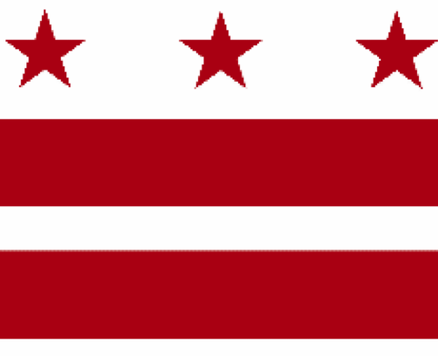

Government of the District of Columbia
ADVISORY NEIGHBORHOOD COMMISSION 3/4G
Chevy Chase, Barnaby Woods, Hawthorne
5601 Connecticut Avenue N.W. P.O. Box 6252 Washington, D.C. 20015
3G@anc.dc.gov | http://www.anc3g.org | YouTube: ANC3G | Office: 202.363.5803

COMMISSIONERS
3/4G-01 - Lisa R. Gore, Vice Chair 3/4G-02 - John Higgins, Treasurer
3/4G-03 - Randy Speck, Chair 3/4G-04 - Michael Zeldin 3/4G-05 - Connie K. N. Chang
3/4G-06 - Peter Gosselin, Secretary 3/4G-07 - Charles Cadwell

____________________________________________________________________________

Agenda
ANC 3/4G Public Meeting
June 27, 2022
Zoom Meeting, 7:00-9:00 pm
Register for Video Meeting here

7:00 Introductions, announcement of meeting procedures (described below), and adoption of agenda

7:05 Commissioner Announcements

7:15 Community Announcements

7:20 Discussion and possible vote on Knollwood’s application to renew its class C Restaurant liquor license (License Number ABRA-096716) (Commissioner Speck)

7:30 Presentation by Historic Chevy Chase DC on grant application to restore call boxes in the community (Commissioner Chang)

7:45 Discussion with Christopher Geldart, Deputy Mayor for Public Safety, regarding enhancing public safety in apartment buildings (Commissioner Gosselin)

8:15 Discussion and possible vote on creation of a Standing Committee on Zoning, Design, and Development to advise the Commission on implementation of the Chevy Chase Small Area Plan, report on the Office of Planning’s response to the Commission’s May 9, 2022 resolution, and discussion and possible vote on testimony at the Council’s July 5, 2022 hearing on PR 24-789, “Chevy Chase Small Area Plan Approval Resolution of 2022” (Commissioners Gosselin, Chang, and Speck)

8:55 Commission Business:

1. Minutes: June 13, 2022
2. Checks: payment to Randy Speck — Zoom Reimbursement: $222.58
3. Possible items for July 11, 2022 meeting: discussion with District Bridges regarding needed improvements to Chevy Chase Main Street; presentations and discussion on improving pedestrian access to Chevy Chase Circle

If you are not able to attend the ANC’s public meeting, you may submit your written comments to 3G@anc.dc.gov. Videos of the ANC’s meetings are available on YouTube channel ANC3G.

Virtual Meeting Procedures: The ANC’s meetings are run with a few norms in mind, and we expect everyone to abide by these norms. They promote a civil and respectful discourse.

- Residents are encouraged to send any questions or comments to the Chair at 3G03@anc.dc.gov in advance of the meeting so that they can be addressed during the meeting.
- Except when they are recognized to speak, all attendees to the virtual meeting should mute their devices to avoid disruptions from background noises.
- Meetings will follow the agenda and the times listed there, with any modifications determined by the Chair.
- After a presenter completes his or her statement, Commissioners ask questions, and then residents have an opportunity to ask their questions or make comments.
- During meetings, residents should use the chat function to ask questions or to request to make a comment; they will then be recognized by the Chair.
- Speakers must limit any statements or questions to the time allotted. The Commission also accepts emailed and written comments or questions.
- Every resident will have an opportunity to be heard once on an issue before any resident is heard twice.
- We understand that sometimes issues may provoke strong emotions and that these expectations may be forgotten. Part of the Chair’s job is to remind you of these norms during the meeting.

