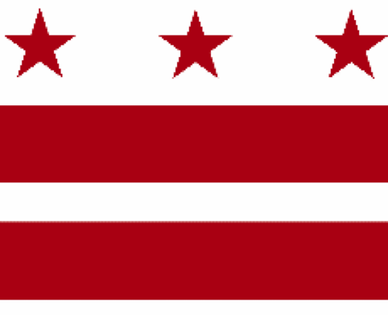

Government of the District of Columbia
ADVISORY NEIGHBORHOOD COMMISSION 3/4G
Chevy Chase, Barnaby Woods, Hawthorne
5601 Connecticut Avenue N.W. P.O. Box 6252 Washington, D.C. 20015
3G@anc.dc.gov | http://www.anc3g.org | YouTube: ANC3G | Office: 202.363.5803

COMMISSIONERS
3/4G-01 - Lisa R. Gore, Vice Chair 3/4G-02 - John Higgins, Treasurer
3/4G-03 - Randy Speck, Chair 3/4G-04 - Michael Zeldin 3/4G-05 - Connie K. N. Chang
3/4G-06 - Peter Gosselin, Secretary 3/4G-07 - Charles Cadwell

____________________________________________________________________________

Agenda
ANC 3/4G Public Meeting
July 11, 2022
Zoom Meeting, 7:00-9:00 pm
Register for Video Meeting here

7:00 Introductions, announcement of meeting procedures (described below), and adoption of agenda

7:05 Election of New Chair

7:10 Commissioner Announcements

7:20 Community Announcements

7:25 Presentations by and discussion with the District Department of Transportation and the Maryland State Highway Administration on improving pedestrian access to Chevy Chase Circle (Commissioners Gosselin and Speck)

8:00 Discussion with Christopher Geldart, Deputy Mayor for Public Safety, regarding enhancing public safety in apartment buildings (Commissioner Gosselin)

8:40 Discussion and possible vote on Historic Chevy Chase DC’s application for a grant to restore call boxes (Commissioner Chang)

8:50 Commission Business:

1. Minutes: June 13, 2022
2. Checks: payment to Randy Speck — Zoom Reimbursement: $222.58
3. Possible items for July 25, 2022 meeting: report on and discussion of the Connecticut Avenue Reversible Lanes and Multimodal Safety Project; discussion with District Bridges regarding needed improvements to Chevy Chase Main Street

If you are not able to attend the ANC’s public meeting, you may submit your written comments to 3G@anc.dc.gov. Videos of the ANC’s meetings are available on YouTube channel ANC3G.

Virtual Meeting Procedures: The ANC’s meetings are run with a few norms in mind, and we expect everyone to abide by these norms. They promote a civil and respectful discourse.

- Residents are encouraged to send any questions or comments to the Chair at 3G03@anc.dc.gov in advance of the meeting so that they can be addressed during the meeting.
- Except when they are recognized to speak, all attendees to the virtual meeting should mute their devices to avoid disruptions from background noises.
- Meetings will follow the agenda and the times listed there, with any modifications determined by the Chair.
- After a presenter completes his or her statement, Commissioners ask questions, and then residents have an opportunity to ask their questions or make comments.
- During meetings, residents should use the chat function to ask questions or to request to make a comment; they will then be recognized by the Chair.
- Speakers must limit any statements or questions to the time allotted. The Commission also accepts emailed and written comments or questions.
- Every resident will have an opportunity to be heard once on an issue before any resident is heard twice.
- We understand that sometimes issues may provoke strong emotions and that these expectations may be forgotten. Part of the Chair’s job is to remind you of these norms during the meeting.

