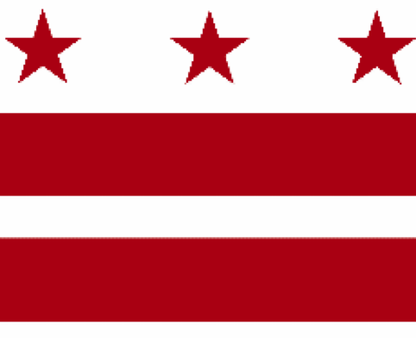

Government of the District of Columbia
ADVISORY NEIGHBORHOOD COMMISSION 3/4G
Chevy Chase, Barnaby Woods, Hawthorne
5601 Connecticut Avenue N.W. P.O. Box 6252 Washington, D.C. 20015
3G@anc.dc.gov | http://www.anc3g.org | YouTube: ANC3G | Office: 202.363.5803

COMMISSIONERS
3/4G-01 - Lisa R. Gore, Chair 3/4G-02 - John Higgins, Treasurer
3/4G-03 - Randy Speck, Vice Chair 3/4G-04 - Michael Zeldin 3/4G-05 - Connie K. N. Chang
3/4G-06 - Peter Gosselin, Secretary 3/4G-07 - Charles Cadwell

____________________________________________________________________________

Agenda
ANC 3/4G Public Meeting
December 12, 2022
Zoom Meeting, 7:00-9:00 pm
Register for Video Meeting here

7:00 Introductions, announcement of meeting procedures (described below), and adoption of agenda

7:05 Commissioner Announcements

7:15 Community Announcements

7:30 Progress Update on Broad Branch and Spring Valley Stormwater Retrofit Project - permeable alley behind 5800 Nevada Avenue (Commissioner Chang)

7:45 2022 Elections: Presentation, Debrief, and Q&A with the Board of Elections – Gary Thompson, Chair (Speck)

8:00 Discussion and Possible Vote on Resolution on Task Force on Racism Recommendations (Commissioner Gore)

8:30 ANC Committee and Task Force Reports
1. Zoning, Design, and Development Standing Committee (Gosselin)
2. Racial and Social Equity Standing Committee (Gore)
3. Maret Project Task Force (Gore)

8:50 Commission Business:

1. Minutes: October 20, 2022 and November 28, 2022
2. Check Payments
3. Discussion and vote on FY 2023 Budget
4. Possible items for January 9, 2023 meeting: Election of new officers; adoption of by-laws; adoption of 2023 meeting schedule; adoption of resolution approving the ANC’s participation in the Advisory Neighborhood Commission Security Fund and authorizing the Treasurer to pay the $25 fee for the period January 1, 2023, through December 31, 2023; ANC Code of Conduct Resolution

If you are not able to attend the ANC’s public meeting, you may submit your written comments to 3G@anc.dc.gov. Videos of the ANC’s meetings are available on YouTube channel ANC3G.

Virtual Meeting Procedures: The ANC’s meetings are run with a few norms in mind, and we expect everyone to abide by these norms. They promote a civil and respectful discourse.

- Residents are encouraged to send any questions or comments to the Chair at 3G01@anc.dc.gov in advance of the meeting so that they can be addressed during the meeting.
- Except when they are recognized to speak, all attendees to the virtual meeting should mute their devices to avoid disruptions from background noises.
- Meetings will follow the agenda and the times listed there, with any modifications determined by the Chair.
- After a presenter completes his or her statement, Commissioners ask questions, and then residents have an opportunity to ask their questions or make comments.
- During meetings, residents should use the chat function to ask questions or to request to make a comment; they will then be recognized by the Chair.
- Speakers must limit any statements or questions to the time allotted. The Commission also accepts emailed and written comments or questions.
- Every resident will have an opportunity to be heard once on an issue before any resident is heard twice.
- We understand that sometimes issues may provoke strong emotions and that these expectations may be forgotten. Part of the Chair’s job is to remind you of these norms during the meeting.

